Test Accuracy: 91.30%

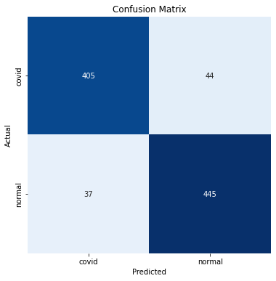

Classification Report:

----------------------

precision recall f1-score support

covid 0.92 0.90 0.91 449

normal 0.91 0.92 0.92 482

accuracy 0.91 931

macro avg 0.91 0.91 0.91 931

weighted avg 0.91 0.91 0.91 931

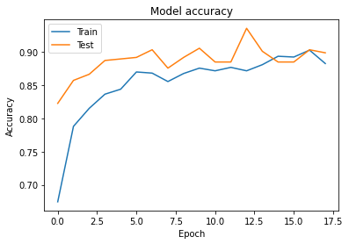

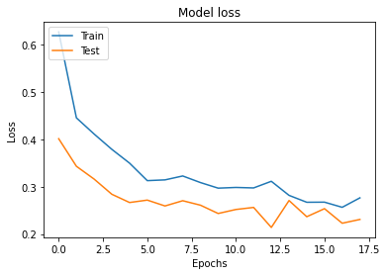

Epoch 1/100

55/55 [==============================] - 349s 6s/step - loss: 0.6263 - accuracy: 0.6745 - val_loss: 0.4010 - val_accuracy: 0.8226 - lr: 0.0010

Epoch 2/100

55/55 [==============================] - 59s 1s/step - loss: 0.4450 - accuracy: 0.7880 - val_loss: 0.3429 - val_accuracy: 0.8571 - lr: 0.0010

Epoch 3/100

55/55 [==============================] - 59s 1s/step - loss: 0.4109 - accuracy: 0.8151 - val_loss: 0.3159 - val_accuracy: 0.8664 - lr: 0.0010

Epoch 4/100

55/55 [==============================] - 59s 1s/step - loss: 0.3786 - accuracy: 0.8364 - val_loss: 0.2839 - val_accuracy: 0.8871 - lr: 0.0010

Epoch 5/100

55/55 [==============================] - 59s 1s/step - loss: 0.3495 - accuracy: 0.8439 - val_loss: 0.2665 - val_accuracy: 0.8894 - lr: 0.0010

Epoch 6/100

55/55 [==============================] - 59s 1s/step - loss: 0.3126 - accuracy: 0.8698 - val_loss: 0.2716 - val_accuracy: 0.8917 - lr: 0.0010

Epoch 7/100

55/55 [==============================] - 59s 1s/step - loss: 0.3142 - accuracy: 0.8681 - val_loss: 0.2592 - val_accuracy: 0.9032 - lr: 0.0010

Epoch 8/100

55/55 [==============================] - 58s 1s/step - loss: 0.3225 - accuracy: 0.8554 - val_loss: 0.2703 - val_accuracy: 0.8756 - lr: 0.0010

Epoch 9/100

55/55 [==============================] - 58s 1s/step - loss: 0.3086 - accuracy: 0.8675 - val_loss: 0.2609 - val_accuracy: 0.8917 - lr: 0.0010

Epoch 10/100

55/55 [==============================] - 58s 1s/step - loss: 0.2968 - accuracy: 0.8756 - val_loss: 0.2434 - val_accuracy: 0.9055 - lr: 0.0010

Epoch 11/100

55/55 [==============================] - 58s 1s/step - loss: 0.2983 - accuracy: 0.8715 - val_loss: 0.2518 - val_accuracy: 0.8848 - lr: 0.0010

Epoch 12/100

55/55 [==============================] - 58s 1s/step - loss: 0.2973 - accuracy: 0.8767 - val_loss: 0.2561 - val_accuracy: 0.8848 - lr: 0.0010

Epoch 13/100

55/55 [==============================] - 58s 1s/step - loss: 0.3112 - accuracy: 0.8715 - val_loss: 0.2140 - val_accuracy: 0.9355 - lr: 0.0010

Epoch 14/100

55/55 [==============================] - 58s 1s/step - loss: 0.2816 - accuracy: 0.8808 - val_loss: 0.2706 - val_accuracy: 0.9009 - lr: 0.0010

Epoch 15/100

55/55 [==============================] - 58s 1s/step - loss: 0.2670 - accuracy: 0.8934 - val_loss: 0.2366 - val_accuracy: 0.8848 - lr: 0.0010

Epoch 16/100

55/55 [==============================] - 58s 1s/step - loss: 0.2673 - accuracy: 0.8923 - val_loss: 0.2535 - val_accuracy: 0.8848 - lr: 0.0010

Epoch 17/100

55/55 [==============================] - 58s 1s/step - loss: 0.2564 - accuracy: 0.9026 - val_loss: 0.2228 - val_accuracy: 0.9032 - lr: 1.0000e-04

Epoch 18/100

55/55 [==============================] - 59s 1s/step - loss: 0.2764 - accuracy: 0.8825 - val_loss: 0.2308 - val_accuracy: 0.8986 - lr: 1.0000e-04

INFO:tensorflow:Assets written to: /content/drive/MyDrive/vgg19/assets

Test Loss: 0.22617

Test Accuracy: 91.30%